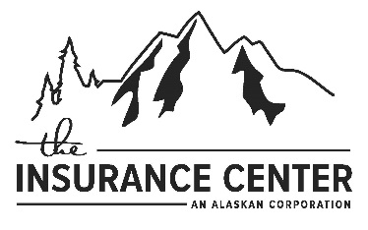

Name of Insured: Phone #:
Property Location:
Email (optional):
Waiting Period

Loan Closing (no wait)-please give the date of closing: Lender Required (no wait)
Rollover/Renewal - Please give the renewal date: 30 day wait

Mailing same as Property Address? Yes No
If no, please provide:

Mortgaged Property? Yes No
If yes, Mortgagee name:
Mortgagee address:
Loan Number:
Essential Rating Elements
- What is the community’s name and number?
- Flood Zone Construction Date:
- Is the coverage for a condominium building? No Yes If yes, Number of Units:
- Is the coverage for a condominium unit? Yes No
- What is the building’s occupancy type? Single Family 2-4 Family Non-residential Other Residential
- How many floors does the building have (including the basement and crawlspace)?
- What is the basement/enclosure type? None Finished Unfinished
- Elevators No Yes If yes, how many?
- What is the amount of coverage requested for the building? $
- What is the building’s estimated replacement cost? $
- What is the amount of coverage requested for contents? $
- Where are the contents located? N/A (not insuring contents) Basement Only
Basement and above Lowest floor only-above ground level
Lowest floor only-above ground level & higher floors Above ground level-more than one full floor
- What is the requested deductible? $1000 ( standard post-FIRM) $2000 (standard pre-FIRM)
$3000 $4000 $5000
Higher deductibles for Other Residential and Non Residential only: $10,000 $15,000 $20,000 $25,000
$50,000 (only when insuring building and contents)
- Attached garage? No Yes If yes, provide square footage
Is garage used solely for parking of vehicles, building access, and/or storage? No Yes
Is the garage finished (more than 20 linear feet of finished wall, paneling? No Yes
Number of permanent openings (vents) within 1 ft. of adjacent grade:
Total area of all permanent openings: square inches
- Approximate distance to nearest shoreline: Source of Flooding?( e.g. river, lake, etc.)
- Is the building located on Federal Land? No Yes

Please note: If building is Post FIRM construction, located in any of the ‘A’ or ‘V’ zones, an elevation certificate will be required for rating. If applicable, please include a copy of the elevation certificate with this rating sheet. If the Elevation Certificate shows a Diagram number 6, 7, 8, or 9 then please provide the square footage of the enclosure/crawlspace.

For mobile homes only: If the structure to be insured is located in a mobile home park, please provide the year the park was established as the date of construction. If the structure is located on private property, please provide the date it was placed on permanent foundation on that property.

Agency Name:
Agent Name:
Agent Email:

