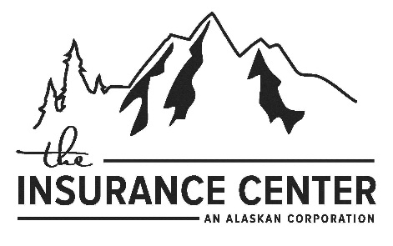

ALASKA

ORDINANCE OR LAW REJECTION FORM

The undersigned policyholder or applicant acknowledges and understands he/she has rejected coverage for losses that result from enforcement of ordinances or laws regulating restoration of a building following physical damage to that building by a covered cause of loss.

This rejection of Ordinance or Law coverage is valid and binding on all Insureds and persons claiming benefits under the policy/application.

The undersigned acknowledge that he/she has rejected Ordinance or Law coverage at this time.

PENN-STAR INSURANCE
Insurance Company |  | Policy /Application Number

Policy Holder /Applicant (Print)
Signature |  | Date
Insurance Agent/Broker (Print)
Signature |  | Date

