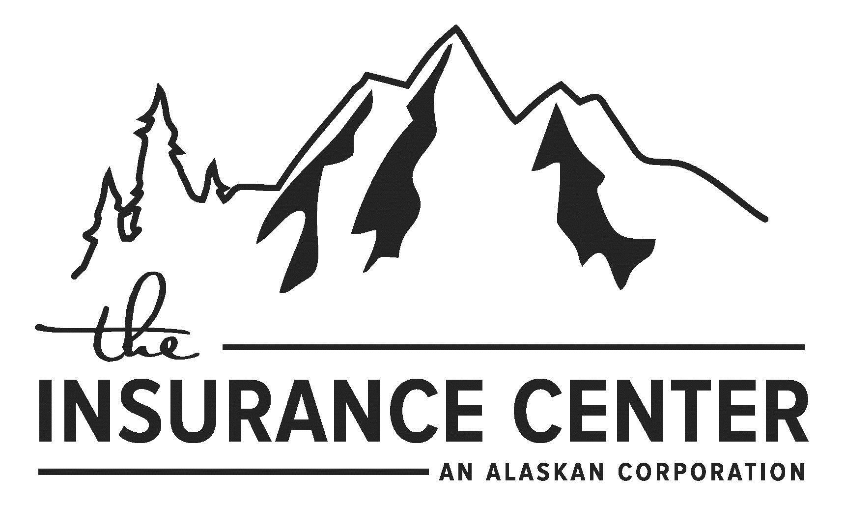

IMPORTANT INFORMATION

POLICYHOLDER DISCLOSURE

NOTICE OF INSURANCE COVERAGE FOR ACTS OF TERRORISM

You are hereby notified that under the Terrorism Risk Insurance Act of 2002, effective November 26, 2002, you have a right to purchase insurance coverage for losses arising out of acts of terrorism, as defined in Section 102(1) of the Act, subject to all applicable policy provisions. The term “act of terrorism” means any act that is certified by the Secretary of the Treasury, in concurrence with the Secretary of State, and the Attorney General of the United States—to be an act of terrorism; to be a violent act or an act that is dangerous to human life, property; or infrastructure; to have resulted in damage within the United States, or outside the United States in the case of an air carrier or vessel or the premises of a United States mission; and to have been committed by an individual or individuals acting on behalf of any foreign person or foreign interest, as part of an effort to coerce the civilian population of the United States or to influence the policy or affect the conduct of the United States Government by coercion.

You should know that coverage provided by this policy for losses caused by certified acts of terrorism is partially reimbursed by the United States under a formula established by federal law. Under this formula, the United States pays 90% of covered terrorism losses exceeding the statutorily established deductible paid by the insurance company providing the coverage. The premium charged for this coverage is provided below and does not include any charges for the portion of loss covered by the federal government under the Act.

PLEASE SELECT ONE OF THE FOLLOWING TO EITHER ACCEPT OR REJECT TERRORISM INSURANCE COVERAGE:

I hereby elect to purchase coverage for losses arising out of certified acts of terrorism, as defined in the Act and subject to all applicable policy provisions, for a premium of $ plus any applicable tax which may apply , for the period of to _. You should know that your policy does not provide coverage for acts of terrorism that are not certified by the Secretary of the Treasury.

I hereby reject coverage for losses arising out of certified acts of terrorism, as defined in the Act. I
understand that losses arising out of terrorism will be excluded

Type or print Policyholder/Applicant Name:

Policyholder/Applicant Signature:

Policyholder/Applicant’s Title: Policy Number:
Date:

Please return the original form to us through your agent. We recommend that you keep a copy of this notice for your records.

MUS 01 01 TRIA 0612

